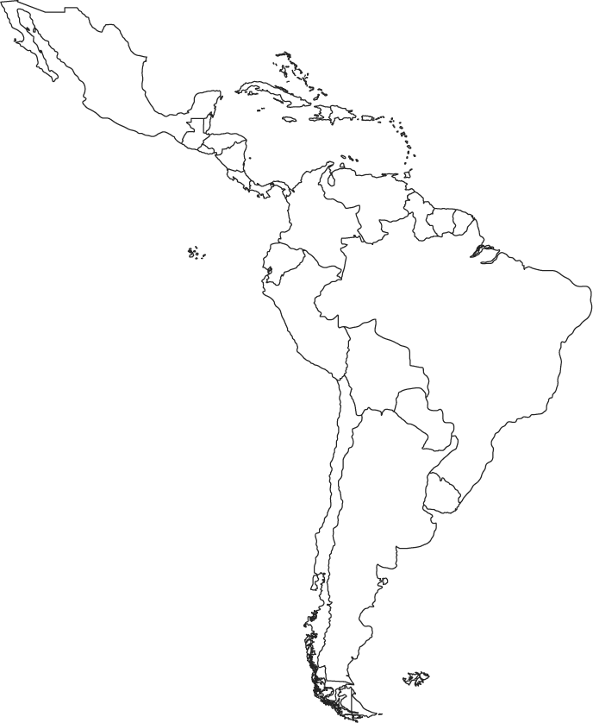

Name_____________________________

Period_____________________________

LATIN AMERICA POLITICAL MAP