Europe WWII Name_________________________________Period_____
Operation Torch-
Operation Sledgehammer-
Operation Overlord-
Instructions:
A. Open the Interactive map on my website (WWII tab). Color the water blue & label the countries.
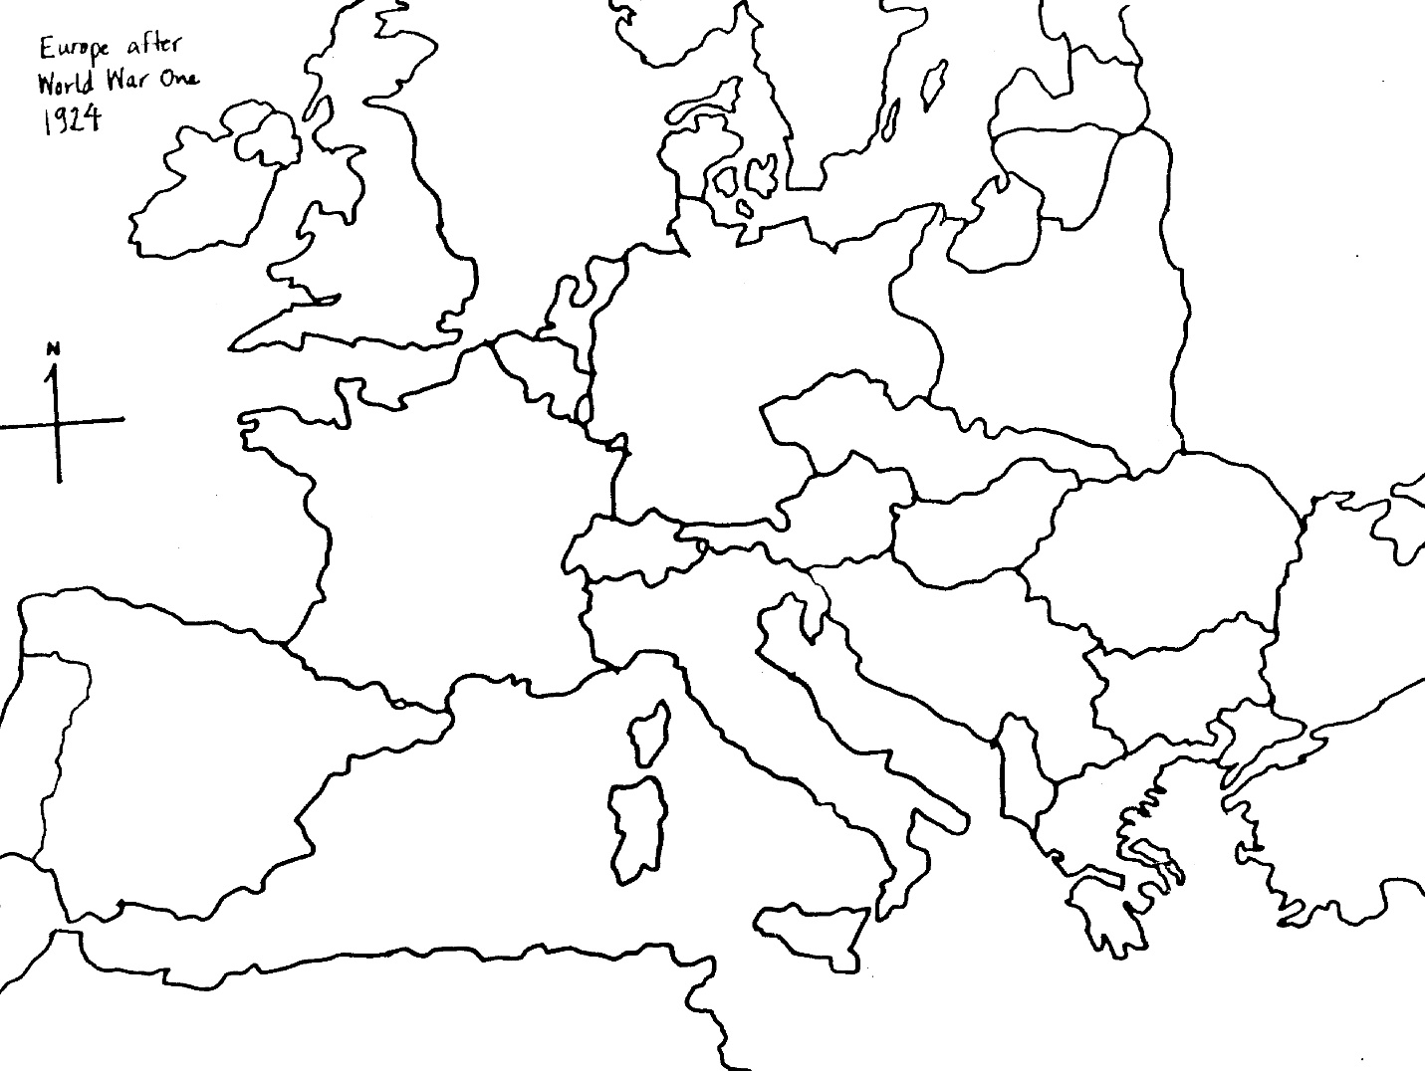B. Hover the cursor over each dot, find the date of the event put in chronological order. After reading the information, write summary of the event below in correct chronological order. Record the event number on map above.
1. | 6. | 11.
2. | 7. | 12.
3. | 8. | 13.
4. | 9.
5. | 10.

