Boycott of Jewish Businesses
P 9
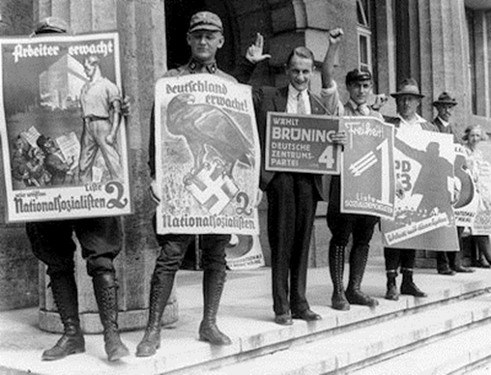
Adolph Hitler and his National Socialist, or Nazi, party came to power in Germany in 1933. The Nazis had grown increasingly popular within Germany in the 1920’s and early 1930’s because of Hitler’s fierce attacks on the Treaty of Versailles, which many Germans believed was unfair in its punishment of Germany. In addition, Hitler gave Germans a convenient scapegoat—the Jews—for Germany’s problems. Capitalizing on deeply rooted anti- Semitism (hundreds of anti-Jewish laws had been passed throughout Europe at different times for over 2,000 years, and pogroms—organized massacres—of Jews were not uncommon), Hitler publicly blamed the Jews for Germany’s loss of World War I and its failing economy. Quickly, Hider’s ideas were widely accepted in Germany.

Two months after being appointed Chancellor of Germany, Hider announced a boycott of all Jewish shops, goods, doctors, and lawyers. The purpose of the boycott was to isolate Jews both socially and economically from German society. The boycott legislation (laws) also intended to demonstrate to the nation and the world that Hider was firmly in control of Germany.

The boycott laws established an official channel for the outpouring of hatred and jealousy that had swept the Nazis into power. Tens of thousands of Jews were fired from their jobs and banned from universities. Jewish businesses were marked with stars in the windows and often attacked and terrorized by hooligans. The boycott caused a great uproar in other nations, and the Nazis, fearing further damage to their economy, quickly ended it Still, the boycott provide a glimpse of the plan that would later lead to the devastation of Jews in Germany and throughout Europe.

Stop here and discuss
- Why did the Nazis become increasingly popular in Germany in the 1920’s and discuss and early 1930’s?
- What did Hitler blame the Jews for?
- What were two of the main goals of the boycott?
- What were some results of the boycott?
Resistance to the Boycott of Jewish Shops and Businesses
P 10
In Germany, the Jews were divided on how to respond to the announced boycott. Many were from families who had lived in Germany for generations and did not believe that Hitler was a great threat These Jews also felt loyalty to their homeland and thought they could help Germany come out of its economic depression. Others disagreed and thought emigration (leaving the country) was the only response to the rise in vocal and active anti-Semitism. Typically, those who left had a place to go where they could join friends or relatives, and did so even though it was difficult to receive exit visas and they were forced to pay high taxes upon leaving Germany. Many Jewish immigrants encountered hostility from other Europeans who were opposed to massive Jewish immigration into their countries.

Meanwhile, in the United States, Rabbi Stephen S. Wise, the head of the American Jewish Congress, called for a rally against the boycott of the Jews in Germany. He invited Jews from all over the United States to protest the worsening of conditions of Jews in Nazi Germany. Some Jews in Germany were afraid this rally would further endanger their position and urged their fellow Jews in the United States to cancel it. Ultimately, the rally took place despite these concerns.

As a result of this rally and subsequent pressure on Hitler by some members of the Nazi party (who feared that the boycott might worsen an already failing economy), the boycott was held for only one day. The boycott represented the first in a series of increasingly drastic measures to persecute (to harass and cause to suffer) Jews in Germany and throughout Europe
Stop here and discuss
- Describe the different ways in which Jews in Germany responded to the boycott.
- What obstacles did Jews face who decided to leave Germany?
- What did Rabbi Stephen S. Wise do in response to the boycott? How successful were his efforts?

The Nuremberg Laws
P 11

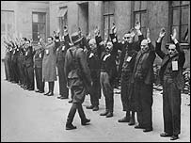
Between the years of 1933 and 1935, hundreds of laws were passed by the Nazis that restricted the freedom of Jews living in Germany. Jews were forbidden to enter movie houses, restaurants, public swimming pools, and other recreation sites. Many anti-Semitic signs appeared, like “Juden Verbaten,” or “Jews not wanted here.” Anti-Semitic propaganda, organized in large part by Hitler Youth (a Nazi training group for young people), and outbreaks of violence against Jews increased. These acts were part of the Nazi party’s stated goal to encourage Jewish emigration (leaving the country) and expropriation (stripping of property and rights).

By 1935, however, Hitler wanted to take more aggressive action against the Jews, so a series of laws placing greater discrimination against Jews was passed by the Nazis. The Nuremberg Laws were legislation designed to separate Aryans from non-Aryans and define the rights of a citizen of the Third Reich (Nazi Germany). The laws established the legal means for assigning Jews inferior status in German society.

The first piece of legislation in the Nuremberg Laws was the Reich Citizenship Law, which distinguished between subjects of the state and citizens of the Third Reich. A subject was “a person who enjoys the protection of the German Reich and who in consequence has specific obligations to it” A citizen, on the other hand, was “a subject of the State who is of German or related blood, who proves by his conduct that he is willing and fit faithfully to serve the German people and Reich.” The Law for the Protection of German Blood and German Honor, among other things, forbade marriages between Jews and those of German or related blood and prohibited Jews from flying the Third Reich flag. In addition, all Jews had to register with the government and wear a yellow Star of David on their clothing so they could be easily identified. The law also carried with it severe penalties for violation of any of its provisions.

- Stop here and discuss
- Between 1933 and 1935, what were some of the anti-Jewish actions Nazis and their supporters took?
- What was the primary goal of the Nuremberg Laws?
- According to the Nuremberg Laws, how were German “subjects” and German “citizens” different?
- What were some of the restrictions the Nuremberg Laws placed on Jews in Germany?

Resistance to the Nuremberg Laws
P 12
In 1933 Jews established the Reichsvertretung der deutschen Juden (National Representation of German Jews) in response to growing prejudice against Jews. The Reichsvertretung was formed to fulfill the following tasks: provide for education and the establishment of Jewish schools, guide Jewish youth toward vocational training, strengthen the religious base of Judaism, protect Jews’ economic status and right to work, and prepare—especially the youth—for building a new life in Palestine (the area that is now Israel) or some other place.

The Reichsvertretung represented new awareness on the part of German Jewry. They realized that they were involved in a struggle for which they were not prepared. As thousands of Jews began to lose their jobs and their homes, Jewish leaders created a framework that would help them withstand persecution. Organizations attempted to defend the economic rights and cultural interests of German Jews.

In 1933 the Committee for Relief and Reconstruction was established as an advisory board equipped to extend legal protection. By 1935 its work had expanded to include economic assistance, advice, loans, legal aid, employment placement, and vocational training.

While it was still possible far Jews to defend themselves against exclusion in the economic sphere, they were forced to forge new ground in the cultural realm. Germany’s Jews were prohibited from participating in German cultural activities and were even restricted in their use of German literary and artistic material. In response, Cultural Associations were established to provide Jews with a framework for independent cultural activity and to create jobs for Jewish artists, intellectuals, and writers. In 1935, 70,000 Jews were members of 36 Cultural Associations that functioned in 49 communities throughout Germany. Cultural activities—which included the presentation of plays, films, lectures, public readings, art exhibits, concerts, and even operas—were often focused on Jewish culture.

The Jewish press in Germany also contributed to building a sense of pride and cultural awareness among Jews. In 1936, 63 Jewish publications existed in Germany. In 1935, Nazis banned two papers for speaking out against the anti-Jewish riots and for carrying reliable information about assaults on Jews and their businesses.

- Stop here and discuss
- What were the main goals of the Reichsvertretung?
- What services did the Committee for Relief and Reconstruction provide?
- Why were Jewish Cultural Associations established? What purpose did they serve?
- How did the Jewish press contribute to resistance to the Nuremberg Laws?

Kristallnacht
P 13
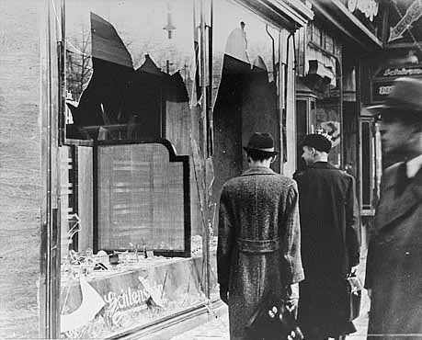
Between 1933 and 1938, nearly 2,000 anti-Jewish laws and edicts changed life for all German Jews. Nearly half of the Jews of Germany emigrated (left the country), but for those who couldn’t or wouldn’t, the situation worsened in November 1938. Nazi officials unleashed a savage nationwide campaign of terror against Germany’s Jewish population known as Kristallnacht, the night of shattered glass. Supposedly in retaliation for the assassination of a German official by a Jewish student, thousands of SS storm troopers (Nazi soldiers) and non-Jewish German sympathizers aimed with hammers, axes, crowbars, and fire bombs went on an anti-Jewish rampage. They looted and smashed windows of Jewish owned stores, destroyed synagogues (places of Jewish worship), and killed and arrested Jews.

In 15 hours, 101 synagogues were destroyed by fire, and 76 others were demolished. 7,500 Jewish-owned stores were destroyed, and over 100 Jews were killed. 30,000 more were arrested and interned in camps. David H. Buffum, an American official stationed in Leipzig, reported that “Jews were being thrown from windows into streets littered with shattered glass...three synagogues in Leipzig had been fire bombed and all sacred objects and records had been destroyed...and that tactics which approached the ghoulish took place at the Jewish cemetery, including uprooting tombstones and violating graves.”

Although Nazi officials attempted to portray Kristallnacht as a spontaneous and popular demonstration of anger, the uprising had been planned for weeks in Berlin by senior government officials and was intended to escalate (increase) the ongoing Nazi effort to dehumanize and bring misery to the Jews. Organized groups knew what to destroy, what to bum, how much violence would be tolerated, and how much the government would benefit from expropriation (taking property) in the aftermath. To complete the horror of Kristallnacht, the German government enacted a fine of one billion marks (approximately $400,000,000) on the Jewish community to pay for the damage caused by the mobs.

- Stop here and discuss
- What fraction of Jews left Germany by 1938?
- What was Kristallnacht?
- Describe what happened during Kristallnacht
- Why did Nazi leaders plan Kristallnacht?

Resistance to Kristallnacht
P 14
The swiftness and magnitude of the violence of Kristallnacht seemed to catch not only the Jewish community, but the entire world, off guard. Immediate responses to Kristallnacht were limited to shock, outrage, and disbelief. Jews who attempted to protect their families, business, and synagogues were dealt with harshly. For the most part, Jewish resistors were taken to concentration camps where they were tortured and humiliated, and many were beaten to death in the streets.

As the Jewish public recovered from the initial shock of Kristallnacht, the response of many was just what the Germans had hoped for—they left Germany. In the first eight months of 1939, until the outbreak of the war in September 1939, 78,000 Jews left Germany, marking the largest number in a single year since 1933. The numbers of emigrants from Austria in 1939 was close to 55,000. Although the Nazis had an open policy, which supposedly encouraged Jews to emigrate from Germany, it was a difficult task for those who chose to leave, for two reasons.

First, as a result of Nazi efforts to destroy the Jewish economic base, many Jews who were once prosperous merchants had become impoverished. Only 40,000 of approximately 100,000 businesses were left by April 1,1938. Second, many countries feared a massive wave of impoverished Jewish refugees and closed their borders to Jews. After Kristallnacht, many Jews fled Germany despite these immigration restrictions, often risking their lives in the process.

Pressed as they were to escape Germany quickly, desperate Jews were often forced into illegal, dangerous, and often bogus emigration schemes. One of the most notorious and heinous incidents was that of the ship Saint Louis. In May 1939, the Germans loaded more than 900 Jews onto the ship with the assurance that their entry into Cuba was guaranteed. When they arrived in the Caribbean, they realized that the Cuban government had invalidated all of their entry permits. The Saint Louis sailed from one country to the next, but its passengers were never allowed to disembark. Eventually, it had no choice but to return to Hamburg, Germany, where the Jews would have been sent to concentration camps. Through great efforts, Jewish organizations ultimately persuaded Belgium, Holland, England, and France to divide the refugees among them.

- Stop here and discuss
- What happened to Jews who resisted Kristallnacht?
- What did 78,000 Jews do in response to Kristallnacht?
- By 1939, why was it difficult for Jews to leave Germany?
- What happened to Jews who tried to leave Germany on the ship Scant Louis?

Jewish Ghettos
P 15
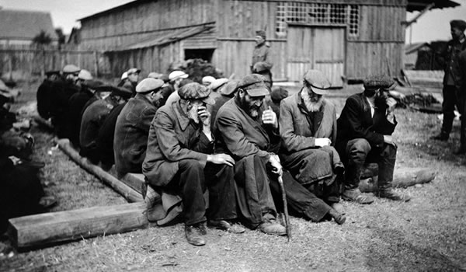
As early as 1938 the Nazis discussed the possibility of segregating the Jewish population in Europe from the non-Jewish population. According to their plan, all Jews were to be forced from their homes and required to live in ghettos. Ghettos were small areas within a city that were sealed off with barbed-wire or high walls. In many ghettos, inhabitants were prohibited from leaving the compound, and no one could enter from the outside. The main reason given by the Nazis for isolating the Jews was the danger that a typhus epidemic would spread through the city. In truth, the Nazis regarded the ghettos as a temporary way to concentrate the Jews until it proved possible to achieve the Nazi party’s stated goal of eliminating, or killing, all of them.

Beginning in 1939, ghettos were established in occupied eastern Europe (regions that Nazi Germany had conquered), which meant that Jews from all over northern and western Europe were transported to eastern European ghettos. The Jews often arrived with only the clothes on their backs because they were only given a few minutes to gather their belongings before being ejected from their homes. The rest of their property was left to looters. German authorities set up special warehouses for collecting the goods that had been confiscated from Jewish businesses and homes once the Jews were removed.

Jews lived in a state of chaos and immense anxiety in the ghettos. People had very few resources, they were sick and malnourished, and they lived in very crowded conditions. Unable to earn money by working, some Jews displayed incredible initiative and resourcefulness in turning junk into useful products that the Germans were willing to trade for food and other goods. Established in November 1940, the Warsaw ghetto in Poland contained nearly 500,000 Jews, many of whom were from outside of Poland. About 45,000 Jews died there in 1941 alone as a result of overcrowding, hard labor, lack of sanitation, starvation, and disease. Those Jews who did not die in the ghettos were ultimately transported to concentration camps to be murdered at the hands of the Nazis. All ghettos were eventually destroyed.

- Stop here and discuss
- What were ghettos?
- Why did the Nazis put Jews into ghettos?
- Where did the Nazis establish ghettos?
- Describe life in the ghettos.

Resistance to the Jewish Ghettos
P 16
A wide range of resistance occurred in ghettos to help preserve some normalcy in Jews’ lives. Jews conducted educational classes, held musical and dramatic performances, and planted gardens on rooftops. Secret newspapers were published to inform ghetto inhabitants of Nazi plans and to urge Jews to maintain hope, to strive for physical and spiritual fitness, and to fight for survival. By preserving community spirit, these forms of resistance helped armed resistance to occur.

Armed revolts broke out in many ghettos, the most famous of which occurred in Warsaw. The Warsaw Ghetto Uprising was planned for several months. Guns and ammunition were smuggled into the ghetto, and bottles filled with gasoline and sealed with rags became homemade bombs. As the resistance fighters prepared, the Nazis continued rounding up Jews in the Warsaw ghetto to send to the concentration camps where they would be killed.

In January 1943, with only 70,000 Jews left in the ghetto, a small revolt broke out As a result Nazi leaders decided to transport all of the remaining Jews to concentration camps and to destroy the Warsaw ghetto. When the German tanks rolled into the ghetto, 1,000 Jewish fighters were ready for them. The Germans were taken by surprise when grenades and bombs blew up their leading tanks, and they were forced to retreat

The next day, in revenge, the German soldiers broke into a Jewish hospital. They walked through the halls shooting and killing everyone they found and then set the building on fire. Several days of Nazi attacks followed. They tried searching one building at a time for hidden Jews, but wherever they turned, they found resistance fighters. After two weeks of fighting, the Jews began running out of ammunition. They used weapons taken from dead German soldiers. The Germans used flame throwers, artillery, and bombs.

The fighting continued until May 8, 1943 when the Germans finally reached the central command post of the Jewish fighters. Over 100 resistance fighters were killed on the spot. Many suffocated when the Germans threw gas bombs into the building. Others chose to take their own lives. Then the Germans blew up the Warsaw synagogue and several other buildings. Small groups of Jews hid in bunkers below the destroyed buildings, while others escaped through the sewers to the Aryan side of the city and to the forests. The Nazis destroyed the entire ghetto and most of the Jews that had once lived in it News of the uprising spread through the concentration and labor camps, inspiring many more revolts.

- Stop here and discuss
- What were ongoing forms of nonviolent resistance in the ghettos?
- Describe what happened during the Warsaw Ghetto Uprising.
- What was the result of the Warsaw Ghetto Uprising?

Camps
P17
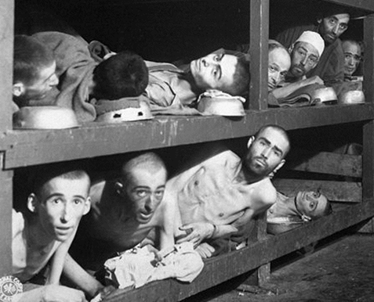
Prisoner-of-war camps, forced-labor camps, concentration camps, and mass-extermination camps were an integral part of Hitler’s efforts to control and terrorize the population of Europe, first in Germany and later in every territory controlled by the Nazi regime. During World War II, the Nazis set up several thousand camps in which prisoners were starved, tortured, worked to death, and in most cases murdered. Conditions varied widely in different types of Nazi camps, but killing occurred in all camps to some degree. Initially, death was a by-product of forced labor and concentration camps; by 1942 death camps whose sole purpose was to exterminate Jews were established. Anyone considered an enemy of the Nazi regime was detained in the Nazi camps: socialists, clergy of various faiths, Jews, and the physically and mentally handicapped. After 1938, the Nazis also imprisoned criminals in the camps as well as such “asocial” elements as homosexuals, Gypsies, prostitutes, and beggars.

Camps were built in accessible places to allow for huge transports of people to be shipped in daily. Although near railroads and major cities, camps were isolated from the outside world. Each one had a complicated systems of fences and barriers that cut it off from the surrounding area and divided it into distinct sections. The staff areas and living quarters for the commanders and SS were clean and well tended. The prisoner’s living quarters consisted of crowded wooden barracks with beds made of wood boards attached to the walls and stacked one on top of another. The guarded watchtowers, which were built close to one another, and the strong lighting ensured that prisoners could be monitored 24 hours a day.

Prisoners in Nazi camps were subjected to unimaginable terrors from the moment they exited the railway cars. Upon arrival, they had to walk in front of SS doctors who would quickly examine them and, with a wave of a hand, determine whether they would be put to death or to hard labor. At the time, the prisoners often did not know the significance of this division, although many had a sense of impending doom. Many families were broken up at this point, as young children were often sent to death right away because they could not work. While in the camps, the prisoners had no legal rights and no means of defense. Their fate was completely in the hands of the camp’s command and staff. All prisoners were susceptible to suffer torture or the worst possible death for any offense. Chronic hunger, disease, and unsanitary living conditions led to complete physical exhaustion, while the breakup of families and the loss of home and livelihood served to demoralize the prisoners.

- Stop here and discuss
- What different types of camps were established by the Nazis?
- Why did Hitler establish camps? When were they first established?
- In addition to Jews, what other “criminals” did the Nazis put into camps?
- To what terrors were prisoners subjected?

Resistance in the Camps
P 18
Resistance was especially difficult in the camps, where prisoners were almost completely cut off from the free world. The civilian population in the surrounding areas was subject to the death sentence, without a trial, for aiding any prisoner or fugitive. In addition, any attempt at escape or resistance was paid for not only by those who engaged in the activities, but also by those prisoners who did not Despite the odds, many prisoners engaged in acts of resistance. Some prisoners staged revolts, which in most cases ended in death. A vast array of other, more passive forms of resistance occurred in camps, including continued faith in God in the midst of hellish conditions, sharing food with starving prisoners, forming secret poetry societies, working slowly in labor camps, and creating discussion groups to maintain morale.

Some acts of resistance were especially noteworthy. A Jewish woman named Mala Zimetbaum escaped from Auschwitz, a camp in Poland, by stealing a Nazi soldier’s uniform and German documents. When she was recaptured, the Nazis paraded her in front of the whole camp to show the prisoners what would happen to them if they tried to escape. In an act of defiance, Mala began to slash her wrist in an attempt to kill herself before the Nazis could. She was stopped by an officer, whom she slapped while yelling, “Don’t be afraid, girls, the end is near. I am certain of this. I know. I was free.” The Nazis later burned her alive. Mala Zimetbaum became a symbol of courage and resistance.

Anna Heilman was bom in Warsaw, Poland in 1928. During the Warsaw Ghetto Uprising, she lived secretly in the Aryan side of the city and acted as a courier for the ghetto resistance movement. In 1943 Anna and her family were taken to the concentration camp at Auschwitz. There Anna helped in the resistance effort She was inspired by Mala Zimetbaum’s example. Thinking she would die, Anna refused to give her life for nothing.

Anna and her sister both worked in the gunpowder room at the camp. Anna’s sister smuggled gunpowder out of the factory in tiny pieces of cloth that were tied with a string and hidden in a small pocket on the inside of her dress. When the Nazis conducted searches, she untied the string on the cloth and let the small amount of gunpowder spill on the ground. Anna’s sister brought gunpowder out and then passed it on to Anna. Anna gave her share to another girl in the camp, and this girl gave it to another girl who was running between Auschwitz and Auschwitz-Birkenau, another concentration camp in Poland. The fourth girl gave it directly to a man who worked in the crematorium (where prisoners’ dead bodies were burned into ashes). The gunpowder that passed through Anna’s hands was used to blow up Crematorium IV in Auschwitz-Birkenau on October 7,1944. Four girls were executed for their role in the sabotage of the crematorium. Anna Heilman survived the Holocaust

- Stop here and discuss
- What made resistance in the camps difficult?
- What were some forms of passive resistance?
- How did Mala Zimetbaum become a symbol of courage and resistance?
- How did Anna Heilman resist the horrors of the Auschwitz death camp?

Deportations Throughout Europe
P 19
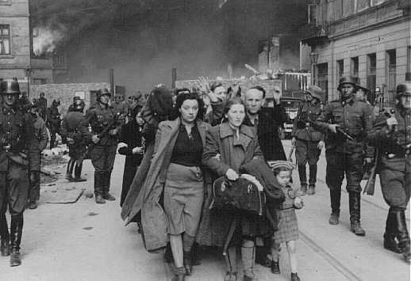
By the end of 1942, the situation for Jews throughout the entire continent of Europe had grown quite grim. With six major death camps operating in Eastern Europe, the Germans had wiped out nearly the entire Jewish population of northeastern Europe by mid 1943. With this task completed, the Nazis increasingly turned their attention to rounding up and deporting Jews from the occupied countries of central, western, and southeastern Europe back to the death camps in the east Ironically, many of the Jews who had fled Germany to what they had hoped would be the safety of the west found themselves facing the same fate as those who had stayed behind.

Unlike the Jews of eastern Europe, who had seen and heard of the earlier massacres and by 1943 understood the purpose of deportation (to be forcibly removed from your country), many of those in western Europe were not fully aware of what awaited them. Among the occupied countries of western Europe, the Dutch Jewish community was the most severely affected. In a single year more than 60,000 Jews were rounded up in massive hunts in the Netherlands and deported by train to the Auschwitz killing center in Poland. In all some 107,000 of the 140,000 Jews who had been living in the Netherlands were deported. And in France, 50,000 Jews—some of whom were from Belgium who had fled to France the German invasion—had been deported by June 1943.

In northern Europe the Germans had less success in rounding up the small Jewish populations of Finland, Norway, and Denmark due to fierce resistance by local governments. However, in southeastern Europe, the Germans used tremendous force in capturing the large Jewish population (50,000) of Salonika, Greece. In a series of dramatic steps, the Germans rounded up the overwhelming majority of Salonika’s Jewish community and others in their zone for deportation to the killing centers in Poland. In March, April, and May of 1943, more than 42,000 Greek Jews were sent to the death camps.

The German campaign to deport all the Jews in Europe’s occupied countries to the killing centers was less successful than the efforts in eastern Europe. However, the Germans anticipated that victory in the war would enable them to complete whatever they had to postpone.

- Stop here and discuss
- By 1942, why had many Jews who had left Germany earlier found themselves facing the same fate as those who had stayed behind?
- What happened to Dutch Jews in the Netherlands?
- From what other European countries did the Nazis try to take Jews?

Resistance to Deportation
P 20
Despite tremendous pressure by Nazis to deport all Jews from the occupied countries of western Europe to the death camps in eastern Europe, hundreds of thousands of lives were saved by individuals and groups who refused to cooperate with the Nazi plans.

Ardrée Geulen Herscovivi was 20 years old when she began volunteering to help save Jewish children in Belgium by removing them from their families and placing them in non- Jewish Belgian homes. Led by their remarkable minister and his equally heroic wife, the people of the village of Le Chambon-sur-Lignon in France sheltered thousands of Jewish refugees from the Germans. In Holland, Marion Van Binsbergen Pritchard, who rescued 150 Dutch-Jewish children during the German occupation, may have best described the motivation for so many individual acts of heroism when she explained, “It did not occur to me to do anything other than what I did.”

Some governments refused to comply with German demands that Jews be deported. One such refusal came at the beginning of October 1943, when the Danish people rescued the great majority of Jews in their country. On October 1, just as the Nazis began their efforts to collect and deport Denmark’s 8,000 Jews, Ferdinand Georg Duckwitza, a member of the German Ambassador’s staff, let the members of the Danish and Swedish government know that the Germans were planning to deport Danish Jews. From inside Denmark, word spread to the Jews, and boat transportation out of the county was arranged. From the outside, the Swedish government announced its willingness to accept Danish Jews over Stockholm radio. In the first days of October, most of Denmark’s Jews were taken to safety in Sweden.

The Italian resistance to the deportation plans particularly annoyed the Nazis and saved a great many lives. Much of the Italian military saw the German mania for killing Jews as barbaric, and, although they were allies with the Germans, refused to deport any Jews from southern France or northern Italy. While the Germans eventually established a killing center in northern Italy following their invasion in 1943, years of Italian resistance saved hundreds of thousands of Jewish lives throughout Italian-occupied Europe.

Resistance to deportation was not limited to the occupied countries. In 1943 the Germans attempted to deport the last sizable group of Jews living in Germany. Most of them had not been deported before because they were married to Aryan women. Before they could be deported, their wives staged a major riot in Berlin. As a result, the police released them.

- Stop here and discuss
- What did some individuals do to resist the Holocaust?
- What did the governments of Sweden and Denmark do to help Jews?
- How did Italy resist Nazi plans for the Jews?
- How did a riot in Berlin successfully resist Nazi plans to deport Jews?
The Final Solution
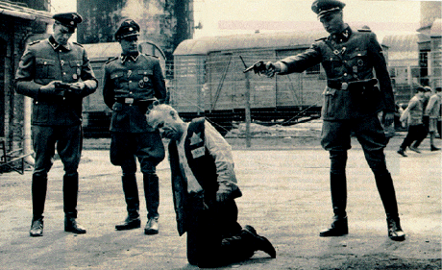
P 21
“This war will not end as the Jew imagines, namely in the liquidation of all European and Aryan Peoples; the outcome of this War will be the extermination of all Jewish People.”
—Adolph Hitler, January 30,1939.

Adolph Hitler often referred to finding a “final solution” to the “Jewish problem.” With the beginning of World War II, the Germans realized that Kristallnacht and the terror that followed would not be enough to drive the Jews out of Germany. By 1940 the Nazis began to devise plans for a mass expulsion of all Jews to the island of Madagascar off the African coast or to reservations in Poland. However, these plans were found to be unworkable.

In 1941 the Einsatzgruppen, special units of the security police and SS Security Service, followed German armies into Russia and set out to kill all Jews as well as Soviet officials, the handicapped, and Gypsies. Victims were executed by mass shootings and buried in mass unmarked graves. Close to one and a half million Jews were killed by the Einsatzgruppen in the Baltics and the Soviet Union.

Nazis began to realize that mass shootings were not an efficient method for killing millions of people. By early 1942, the Nazi leadership committed to move forward with the mass execution of Jews from all over Europe. Death camps were constructed in Poland, where gas was to be the primary means of execution, and the Germans had begun mass deportations of Jews from Germany and Western Europe to the ghettos in Eastern Europe.

Satisfied that the machinery was in place to implement the “final solution,” Nazi leaders met in the Berlin suburb of Wannsee in January 1942. The purpose of the 'Wannsee Conference was to officially coordinate the “final solution.” Participants at the conference openly discussed the various methods of killing Jews, planned how the death camps would be organized, and scheduled the transportation of Jews from all over Europe to Poland.

From 1942 to 1945, the Jews were plunged into a hell of planned murder that neither the Jews nor the majority of modem humanity could have conceived. What made the Holocaust different from other human tragedies was that for the first time the technology and administration of the modem industrial world was organized to murder defenseless people.

In the end, Nazi efforts at a “final solution” to the “Jewish problem” resulted in the death of more than 6,000,000 Jews and millions of others.

- Stop here and discuss
- What were the Einsatzgruppen? What did they do?
- What was the “final solution” to the “Jewish problem”?
- How was the Holocaust different from other human tragedies?

Resistance to the Final Solution
P 22
Resistance to the “final solution” took many forms. For the Jews and others targeted for extermination, to survive was to resist Many Jews successfully ran away, and many more died trying. Among the non-Jewish German population there were individuals and groups who refused to participate in the Nazi’s war on the Jews.

Some Jewish leaders believed that as long as the Germans needed the Jews to work as factory labor, they would not kill them. These leaders encouraged Jews to do whatever it took to make themselves more useful to the Germans. In 1941 the Germans began to issue work cards to those who had a job and to execute those who did not To work was to resist

As the German government pressured factory owners to replace Jewish workers with more “worthy” nationalities, more Jews realized they had no choice but to flee the ghettos or be murdered. Although some Jews were hidden or given aid by non-Jewish friends in villages, most who escaped disappeared into the forests of eastern Europe. This was a difficult decision for young Jews to make, because most Jews were town dwellers and not prepared for life in the forests. Some estimates suggest that tens of thousands of Jews sought refuge in forests. The Jews had no allies among the rural dwellers, and some nationalist groups were hostile toward them. Some Jews were able to form small armies and waged guerrilla war.

Some non-Jewish Germans were willing to help Jews. For example, some German factory owners forged work permits for Jews and lied about how many employees they needed. This was dangerous work, for anyone caught aiding Jews to resist or escape would be jailed or killed.

In 1942 a small number of idealistic young Germans, led by Sophie Scholl and her brother Hans, formed an anti-Nazi group called the White Rose in Munich. The White Rose encouraged students to rise up and rebel against the Nazi regime. The group published and distributed leaflets denouncing the Nazis and the war until early 1943, when they were arrested and sentenced to death. Within hours of being sentenced, Sophie and Hans were beheaded by guillotine.

- Stop here and discuss

- How could working “for” the Germans be a form of resistance?
- What did Jews do who fled ghettos do to survive? What difficulties did they face?
- How did some non-Jewish Germans help Jews?
- What was the White Rase in Munich? What happened to them?
Liberation
P 23
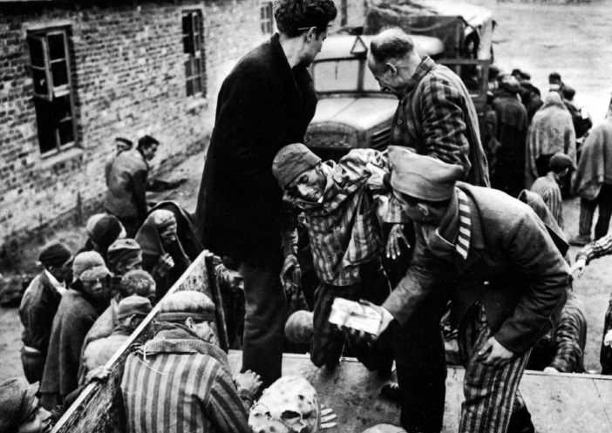
In 1944, as Hitler’s army was being defeated by the Allied forces, concentration camps continued operating. Trains that could have carried Nazi soldiers and military supplies were still carrying Jews to their death. Hitler was determined to continue his extermination of the Jews while at the same time covering up the evidence of the atrocities. Hitler’s troops forced the 300,000 to 400,000 remaining Jews detained in the camps to march east to camps further into his territory. Meanwhile, special units of Jewish prisoners were forced to bum the remains of the millions of Jews-buried- in massive shallow graves throughout eastern Europe. However, bodies could not be destroyed quickly enough and they—along with the millions of shoes, eyeglasses, children’s toys, and clothing—remained as Allied troops liberated the Nazi occupied areas.

From late 1944 to 1945, camp by camp was liberated by the allied forces. The first reports from the Russians were received with disbelief in the West. Yet, as the end neared, the entire world saw with their own eyes the half-starved skeletons and piles of dead bodies left by the Nazi regime. Historians estimate that around 300,000 prisoners were liberated from camps throughout Europe, but many died shortly thereafter from disease and malnutrition. At one concentration camp, Bergen-Belsen, out of the 60,000 remaining inmates, 37,000 died before liberation and 14,000 died after liberation—despite the efforts of a British medical team to save them.

- Stop here and discuss
- What did Hitler do with the Jews as his armies were defeated?
- What evidence of the Holocaust did the Allies find when they liberated concentration camps?
Response to Liberation
P 24
For those who were liberated from the camps, surviving the torture and degradation on a daily basis was an ongoing act of resistance. And those who were able to regain their health, resettle, and thrive in the postwar world were the ultimate resisters to Nazi policies.

After the liberation, the question of what to do with the millions of displaced Jews and Europeans remained. Survivors of the Holocaust were called Displaced Persons, and no country wanted them. The Allies urged them to return to their homes, hoping to ease the burden on relief agencies and to revive their local economies. Many Jews, however, were faced with hostility and discrimination upon returning to the places they had once called home. In Kielce, Poland, for example, 200 Jewish survivors were pelted with stones, clubbed, and shot at by Polish citizens. Forty-two were killed. When news of this attack became known, thousands of Jewish survivors fled from towns and villages throughout Poland to Displaced Persons camps.

Camps for these Displaced Persons were set up in Germany, Austria, and Italy. The camps provided food, clothing, and medical attention. Most of the survivors in the camps wanted to leave quickly, to resettle outside of Europe. But only a fraction of the many who wanted to enter the United States, Britain, or Palestine were allowed in. Immediately after the war the Jewish Brigade, a group of Palestinian Jews, began searching in Germany and Austria for Jewish survivors. In army trucks identified by the Star of David and the blue-white Jewish nation colors, the brigade visited liberated concentration camps and Displaced Person camps to help Jewish survivors come to Palestine. The brigade helped illegally transport thousands of Jews to Palestine. Despite these efforts, there were still approximately 250,000 Jews in the camps in 1947. It was only in 1948, with-the establishment of the state (country) of Israel, that many of these Jews found a home. Some survivors languished in Displaced Persons camps for 11 years.
- Stop here and discuss
- Why do you think surviving the Holocaust is considered an act of resistance?
- How were many Jews received when they returned to their homes?
- What were Displaced Persons camps? What was their function?
- How did the Jewish

