Industrial Revolution Writing Assessment

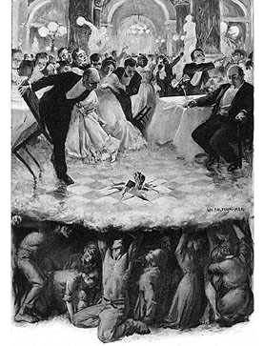

Written Assessment: Two Paragraphs-Remember to frequently reference the rubric.

1. Craft a **well-written paragraph** explaining **to what extent the following is true:**

Particularly in the early years of the Industrial Revolution, the benefits and costs of industrialization and urbanization were unevenly distributed. The middle and upper class enjoyed nearly all of the benefits while the working class was burdened with almost all of the costs.

1. Be sure to include specific evidence and note where you found the evidence. Example (textbook), (costs & benefits chart), etc. (20 pts.)
2. Transition to a second **well-written paragraph explaining the proposed solutions to the problems created by the Industrial Revolution**. (10pts)



|  |  |
| --- | --- |
| Pre-Writing Outline | |
| #1 Topic Sentence: Particularly in the early years of the Industrial Revolution, the benefits and costs of industrialization and urbanization were unevenly distributed.  Evidence#1:  Analysis:  Evidence#2:  Analysis:  Evidence#3:  Analysis:  Evidence#4:  Analysis:  Closing Statement: | #2 Topic Sentence: Solutions to the problems caused by the Industrial Revolution ranged from non-action to violent revolution.    Evidence#1:  Analysis:  Evidence#2:  Analysis:  Evidence#3:  Analysis:  Evidence#4:  Analysis:  Closing Statement: |