Paris Peace Conference
The Paris Peace Conference was a long process of negotiating treaties between the many countries involved in the Great War. The treaty between Germany and the Allies was called the Versailles Treaty. You will be one of the Big Four-the powerful countries that won the war and will attempt to get all your demands into the treaty. A majority wins vote gets demands written into the treaty.
Tasks:
- The group assigns students to their country.
- Read and list your demands:

- Negotiate terms during the time allowed. Record terms that get a majority vote in the box that reflects which country wanted it.
Britain-David Lloyd George  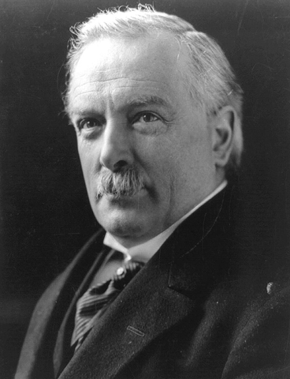 | France-Georges Clemenceau  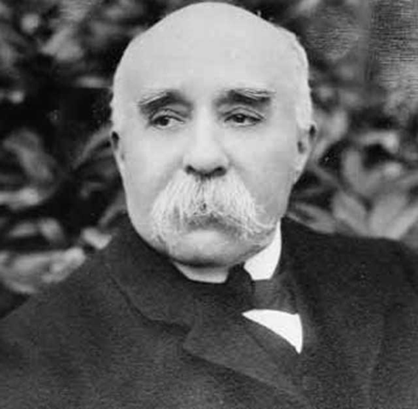
Italy-Vittorio Orlando  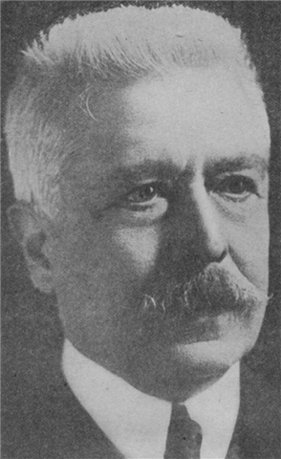 | United States-Woodrow Wilson  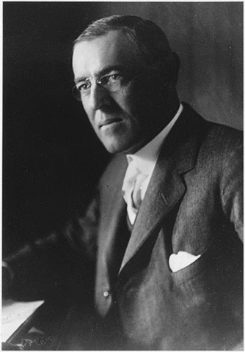
Actual Terms of the Versailles Treaty

European Demands 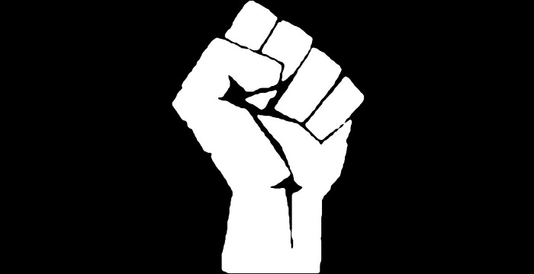 | Wilson’s 14 Points 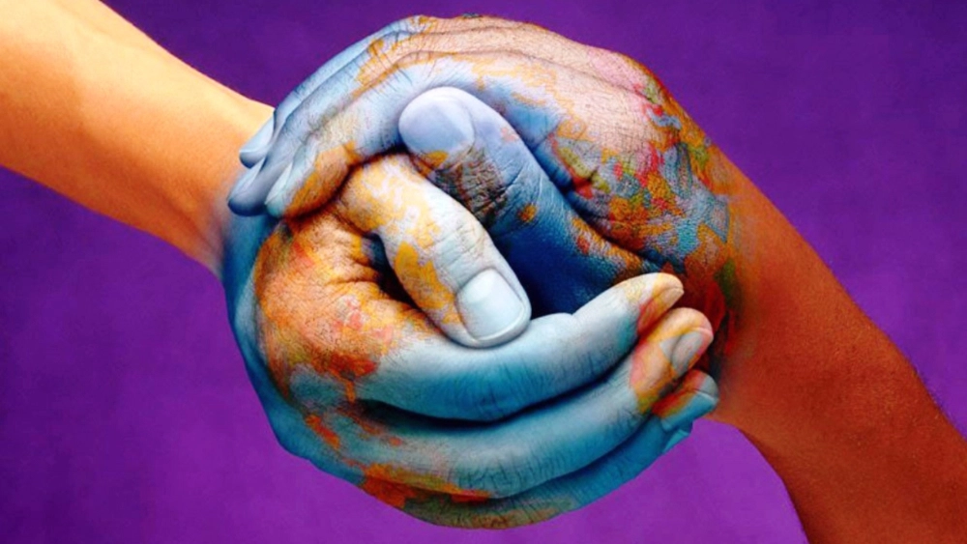

What elements of Wilson’s 14 Points addressed the five long-term causes of WWI?

Militarism-

Imperialism-

Alliances-

Nationalism-

Europe at its Peak-

