WWII Writing Assignment Documents

Document A Commenting on Versailles Treaty, 1930

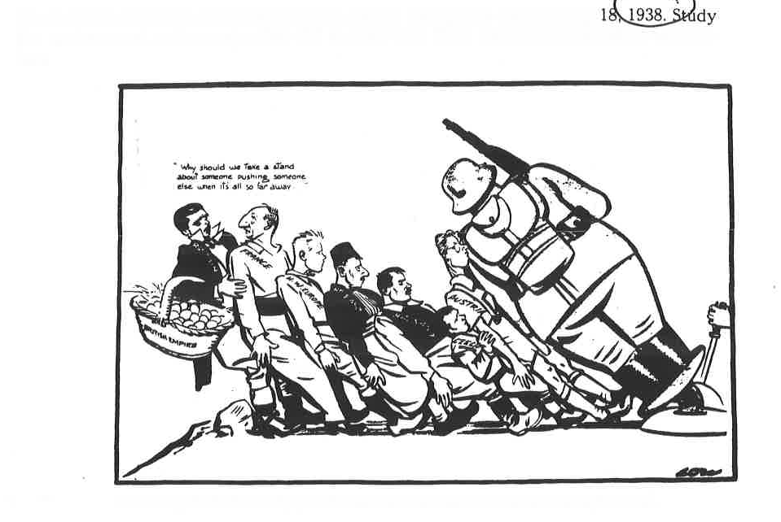

Hitler as Leader of the Nazi Party

Versailles Treaty

Document B Artist is Sir Low (British), 1938

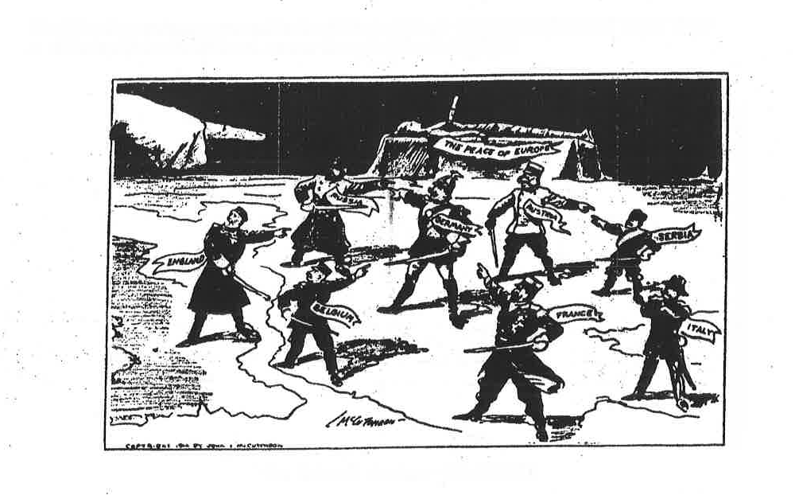

Document D Map of Axis Expansion in Europe by 1941

Document C Chicago Tribune 1914

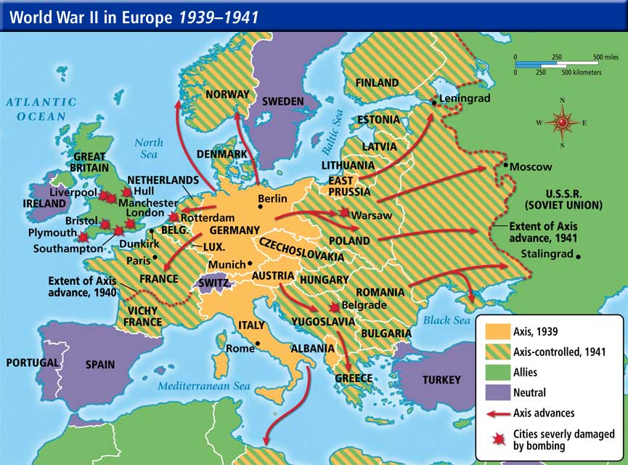

Doc E: Military & Civilian Casualties of WWII

