Name____________________Period____
SCREENPLAY ASSIGNMENT
COSTS & BENEFITS OF INDUSTRIAL REVOLUTION
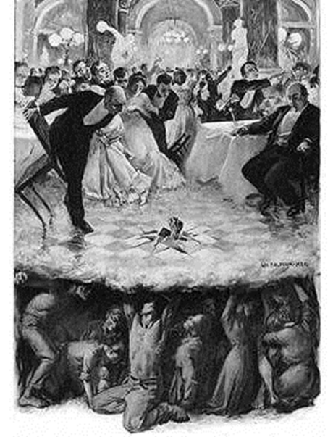
Particularly in the early years of the Industrial Revolution, the benefits and costs of industrialization and urbanization were unevenly distributed. The middle and upper class enjoyed nearly all of the benefits while the working class was burdened with almost all of the costs. After reviewing the image of the struggle between the people working in factories and coal mines during the Industrial Revolution and those benefitting from cheap labor, lower prices and technological advances, write a screen play where each group’s experiences are talked about in a conversation between someone from the lower class and someone from the middle/upper class. Create names and a back story for each character. (Please see example below.) This conversation needs to convey the benefits and costs resulting from the changes launched by the Industrial Revolution.
1) To help get ideas for the screenplay, record answers to all of the following questions including EVIDENCE:
a) What are the BENEFITS of industrialization? Be specific by including EVIDENCE from class notes, the benefits/costs chart, textbook notes, additional research, etc.

b) What are the COSTS of industrialization? Be specific by including EVIDENCE from class notes, the benefits/costs chart, textbook notes, additional research, etc.

c) Brainstorm a list of words that describe what is it like working in the factories and coal mines?

d) Why must labor costs be kept low in order for the benefits of industrialization to be achieved?

e) Brainstorm a list of words that describe what is it like living in urban settings?

2) Lay out the main topics and the order they will be covered in your screenplay conversation:
a.
b.
c.
d.
3) Write a screenplay with a conversation between a member of the lower class and a member of the middle/upper class that incorporates the answers to the above questions and that a) is conversational, b) does not merely list information, c) contains a persuasive tone, and d) reflects bourgeoisie and proletariat perspectives throughout the conversation.
Sample:
Beatrice Smith: (Moved off the farm five years ago after the common area was fenced and recently is employed at a textile factory in London.)
Fredrick Jones: (Used capital gained from recent investments to build a steel mill in London.)
Beatrice: Mr. Jones, I see you are building a steel mill. How many shifts will you be running and what hours do you plan on operating? My son is in need of a job.
Fredrick: Yes, initially, we will run two 10 hour shifts six days a week. This new Bessemer Process . . .

RUBRIC Name_____________________________Period_____
 | Exceeds Standard (27-30) | Meets Standard (21-26) | Below Standard ( 0-20)
Questions Addressed in Screenplay conversation | Thorough answers that reflect the complexities of the questions and/or issues  Clear, Strong, Sophisticated language  All questions addressed | Accurate answers that address or imply an understanding of the issues  Clear, Strong language  All questions addressed | Incomplete/inaccurate answers; minimal understanding of issues  Simple, weak language—includes “I think..,” “I believe…”  Not clear
Conversational/persuasive tone | Extremely Persuasive tone, numerous conversational elements  Strong, Sophisticated language | Persuasive tone, conversational elements  Strong language | Persuasive tone and conversational elements weak or missing  Simple, weak language
Evidence | Abundant, credible, relevant and compelling evidence from textbook, docs, notebook etc. (4 or more) | Reliable and mostly relevant evidence  (3 or more) | Little to no evidence that is questionable or irrelevant  (less than 3)
Analysis | Complex, thoughtful analysis of the evidence is used to prove bourgeoisie/proletariat POV | Evidence is connected to the questions and used to prove bourgeoisie/proletariat POV | General discussion of topic; POV missing

RUBRIC Name_____________________________Period______
 | Exceeds Standard (27-30) | Meets Standard (21-26) | Below Standard ( 0-20)
Questions Addressed in Screenplay conversation | Thorough answers that reflect the complexities of the questions and/or issues  Clear, Strong, Sophisticated language  All questions addressed | Accurate answers that address or imply an understanding of the issues  Clear, Strong language  All questions addressed | Incomplete/inaccurate answers; minimal understanding of issues  Simple, weak language—includes “I think..,” “I believe…”  Not clear
Conversational/persuasive tone | Extremely Persuasive tone, numerous conversational elements  Strong, Sophisticated language | Persuasive tone, conversational elements  Strong language | Persuasive tone and conversational elements weak or missing  Simple, weak language
Evidence | Abundant, credible, relevant and compelling evidence from textbook, docs, notebook etc. (4 or more) | Reliable and mostly relevant evidence  (3 or more) | Little to no evidence that is questionable or irrelevant  (less than 3)
Analysis | Complex, thoughtful analysis of the evidence is used to prove bourgeoisie/proletariat POV | Evidence is connected to the questions and used to prove bourgeoisie/proletariat POV | General discussion of topic; POV missing

