Student Handout 1.2D

Summary of Historical Figures

Directions: Listed below are the historical figures that will take part in the press conference, along with a summary of the views of each on government Use this information to help you prepare for the press conference. This should be especially helpful for the Historians.
Aristotle — Greek philosopher who believed that humans reach their highest potential in organized society and government. Favored a society in which all citizens are educated and participate in governing, but thought this was unrealistic. In his time, favored a system where the king would rule fairly through the guidance of philosophers.

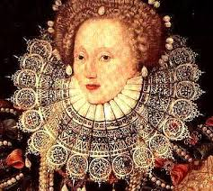
Queen Elizabeth I — Ruled England from 1558 to 1603 as a powerful monarch who shared some political power with Parliament Believed in "Divine Right," the idea that rulers receive their authority from God. Thought that each person is born into his or her proper place in society. Viewed her role as the mother of the people.

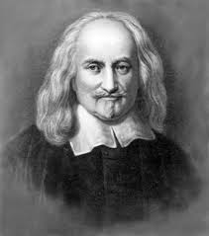
Thomas Hobbes — English philosopher who argued that all humans are naturally wicked. Believed that an absolute monarchy — one that gives all power to a king or queen — is the best form of government. Thought governments were created to protect people from their own selfishness.

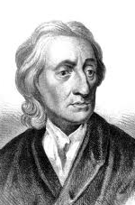
John Locke — English philosopher who believed that people have the ability to reason and make good decisions if given the proper information. Thought governments should be formed only with the approval of the people they are governing. Argued that governments should be established to protect individual freedoms and liberties.

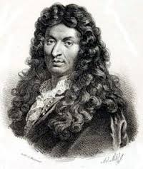
King Louis XIV — Ruled France from 1643 to 1715 as an absolute monarch, a ruler with unlimited power. Believed in "Divine Right," the idea that rulers receive their authority from God and are answerable only to God, not to the people. Was the most powerful ruler of his time.

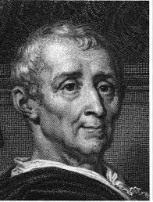
Baron de Montesquieu — French political thinker who believed that a monarchy with limited powers makes a country stable and secure. Established the idea of "separation of powers." This meant government should be divided or spread out among different branches of government so that no individual or group could gain too much power and threaten liberty.

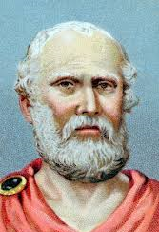
Plato — Greek philosopher who argued that talent determines each person's proper role in society. Believed that everyone should be educated to learn how to become a good citizen. Feared democracy as mob rule, and believed that the ideal government would be rule by a philosopher-king, chosen to rule for his intelligence.

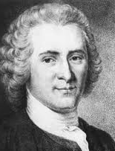
Jean-Jacques Rousseau — Swiss philosopher who believed that society had corrupted the natural goodness in people. Argued that only through direct democracy — where people vote in person to make all laws — can people's freedom be protected.

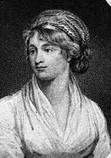
Mary Wollstonecraft — English writer who argued for equal rights for women. Wrote A Vindication of the Rights of Women, in which she argued that women should participate equally with men both in the home and in civic life. Believed women should have equal rights in education, business, and government.

